Day | School | Home | Comments
Monday |  |  | Couldn’t find my bag – really cross  Wanted gaming time to take my mind off it but dad said homework first.
Tuesday | worry, scared, embarrassed | proud | Worried about my line in class assembly. Proud I did it  Really clear delivery in assembly – well done
Wednesday | Excited  Proud |  | None school uniform – got to wear my Arsenal shirt  Great attitude all day – well done
Thursday | Happy | scared | Watched ‘Five night’s at Freddy’s’ as everyone else is. Couldn’t sleep.  PE today – my fav
Friday | 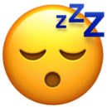  Embarrassed, tired | Embarrassed | Really tired at school cross I was told off in front of everyone for day dreaming  This helped me understand - thanks
 | Morning | Evening
Saturday | 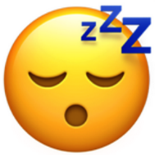 |  | Little brother knocked the laptop and I lost my game – got told off for hitting him  Well done for saying sorry
Sunday |  |  | Scored a goal for my team this morning  Worried about the maths test tomorrow
Happy | Sad
Angry | Scared/worried
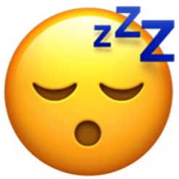  Tired | Leave me alone

