Photo attachment | ……………………………….. Pen Portrait  ……………………. Class
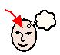
Barriers to Learning
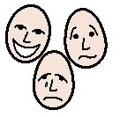  Personality |  |  | 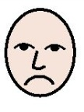  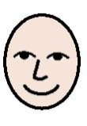  Likes and Dislikes
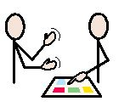
Communication and How to Help me Learn
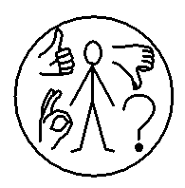Behaviour |  |  | 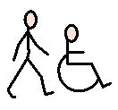  Physical  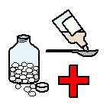  Personal needs and medical

